E();



# Reynoldsburg Lodge #340

**7350 Broadwyn Drive**

**Reynoldsburg, Ohio 43068**

**(614) 866-8179**

[**http://www.mason340.com**](http://www.mason340.com)

|  |  |
| --- | --- |
| **Stated Meetings:** | **1st and 3rd Tuesdays @ 7:30 PM** |
| **Special Meetings:** | **As called by WM** |

# Lodge Officers

|  |  |
| --- | --- |
| **Worshipful Master** | Alexander Jackson |
| [wm@mason340.com](mailto:wm@mason340.com) | 614-371-1424 |
|  | |
| **Senior Warden** | John Wronski, PM |
| [sw@mason340.com](mailto:sw@mason340.com) | 614-861-3883 |
|  | |
| **Junior Warden** | Monroe Bradley |
| [jw@mason340.com](mailto:jw@mason340.com) | 614-866-8439 |
|  | |
| **Secretary** | Gary Wehr, PM |
| secy@mason340.com | 614-202-1523 |
|  | |
| **Treasurer** | Buck Boyd |
| treas@mason340.com | 614-759-4398 |
|  | |
| **LEO** | Charles Ashley |
| [leo@mason340.com](mailto:leo@mason340.com) | 614-861-3425 |
|  | |
| **Trestleboard Editor** | Jack Freund |
| tb@mason340.com | 614-577-1062 |
|  | |
| **Web Editor** | Ken Cohen |
| Ken.Cohen@mason340.com | 614-226-9002 |

**Next Trestleboard Deadline**: 10 March 2015

***Mark Your Calendars!***

# Masonic Calendar

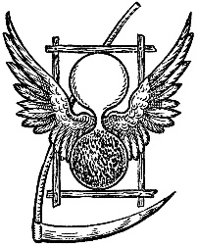

Growing old is no more than a bad habit which a busy man has no time to form. -Andre Maurois

|  |  |  |
| --- | --- | --- |
| **February** | | |
| 3 Feb | 340 Stated Meeting | 7:30P  6:30P – Dinner |
| 5 Feb | Sparrow Lodge #400 | Inspection |
| 14 Feb | Valentine’s Day |  |
| 16 Feb | President’s Day | 7:30P  6:30P – Dinner |
| 17 Feb | 340 Stated Meeting | 7:30P  6:30P – Dinner |
| 19 Feb | Arts & Sciences Lodge #792 | Inspection |
| 24 Feb | Officer’s Meeting | 7:00P |
| 24 Feb | Hiram Lodge #18 | Inspection |
| 26 Feb | District Quarterly Meeting | Groveport Lodge |
| 27 Feb | Capital City Lodge #656 | Inspection |
| 28 Feb | Monthly Breakfast | 8-11A |
|  | | |
| **March** | | |
| 3 Mar | 340 Stated Meeting | 7:30P  6:30P – Dinner |
| 5 Mar | Lockbourne Lodge #232 | Inspection |
| 13 Mar | RR Rickly Lodge #670 | Inspection |
| 14 Mar | Grand Master Reception  @ Villa Milano Restaurant |  |
| 17 Mar | St. Patrick’s Day |  |
| 17 Mar | 340 Stated Meeting | 7:30P  6:30P – Dinner |
| 17 Mar | Sunrise Lodge #783 | Inspection |
| 24 Mar | Officer’s Meeting | 7:00P |
| 28 Mar | Monthly Breakfast | 8-11A |
|  | | |

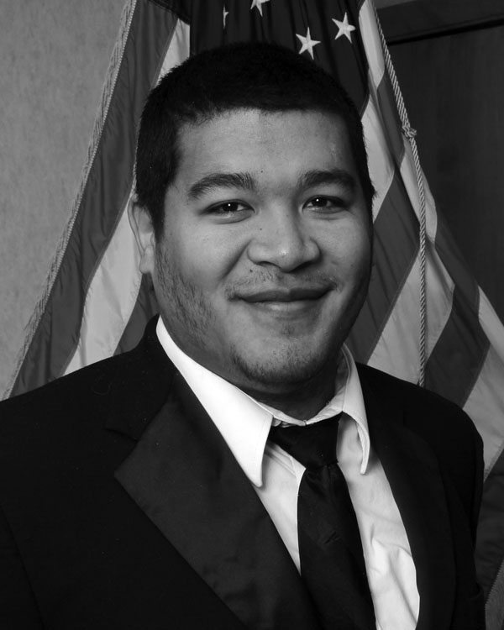

# From the East Alexander Jackson, WM

Greetings from the East Brothers and I wish you all the safest of travels during this winter! Although the weather outside might be a little frightful, inside the sanctuary of our lodge we're enjoying fellowship, food, degree work, and the good old bit of education geared toward making us better men.

The start of our year continued the tradition of Leather Apron Night. We took that opportunity to talk about growth and change in ourselves but also a resolution to look over the brothers in our charge. The chance to talk with a brother about the hopes and desires that you know they have as Masons but also help them choose a Masonic resolution was an interesting reminder of the brotherly love and support we try to give each other.

The Masonic year is already flying by! In just a few months, we brought in a new member by affiliation and now initiated an apprentice into our mystical order. The chance to perform degree work and bring light to a candidate is always an outstanding experience to be a part of and it was great to see the members on the sideline welcoming this newly made Mason. It was wonderful to see our Brothers stepping up and taking on new parts of the degree work, carrying on the traditions, and working towards that perfection which we all desire.

In the coming months, we will be continuing to prepare for inspection with practices. We will also be meeting with brothers outside of the lodge to become better acquainted with the working tools of the speculative Mason. It will be a top priority to make sure that Reynoldsburg Lodge represents its past traditions with another excellent performance of the degree work; particularly since this year, we exemplify the Master Mason degree. Most of our talking parts have been assigned, however the opportunity for brothers to step in as a “walker” is still available to those seeking to be involved.

Past Master’s Night will be the first stated in March. I look forward to these brothers coming back into the lodge even if only momentarily filling the roles that they so honorably held once before…or as in WB Cohen's case, multiple times over! Brothers, it was an honor to meet with you and sit with you once again as the backbone of our Lodge and reflect upon the years of dedication. I also want to thank each of those Past Masters who came to the Officer’s Meeting and gave us their input as to the direction of the lodge as they saw it and what they would like to see in the future.

Brothers, please keep your eyes and ears open for news about upcoming events such as the annual Lady’s Night, fundraisers, Table Lodge, and for those of you who forgot more than you would care to admit, the possibility of a rusty nail degree. Your lodge is still strong and thriving in Reynoldsburg, and is always open, warm, and waiting to welcome you back into our fraternal meeting place.

I look forward to talking to each of you that need to speak with me or even just want to chitchat and shoot the breeze. I’m always happy to receive fraternal correspondence via phone or e-mail. I’ll even be happy to get mail that doesn’t involve a payment envelope.



# K:\DCIM\100CANON\John - TB.jpgFrom the West John Wronski, PM

As we begin a new calendar year, there is a matter which could have a major impact upon the harmony within Reynoldsburg Lodge, as well as Masons around Ohio. At Grand Lodge Session in October, the Grand Code was changed by deleting the prohibitions on gambling, games of chance, etc. Hence, like the rules forbidding a Grand Master's One Day Class, another tradition bit the dust.

This does not mean we will see Lodges turn into casinos. It does open the path to certain activities commonly found in fraternal organizations across the country, such as BINGO and 50/50 raffles. The reasons for this commonality is that the Internal Revenue Code, as well as the Ohio Revised Code, limit games in which tax exempt organizations may engage. MWB Cokonougher, our Grand Master, has issued guidance consistent with the civil laws, so we won't see roulette.

My concern is whether we in Reynoldsburg Lodge should participate in gambling as a means of raising funds. The fact that something is not prohibited does not necessarily make it a good idea. Likewise, other worthwhile groups fundraising through gaming does not require that we follow suit. I see the debate on whether Reynoldsburg Lodge should engage in gambling as a highly volatile one to say the least and recommend that it not occur at all.

[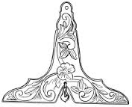](http://www.google.com/imgres?imgurl=http://www.phoenixmasonry.org/enigma_of_freemasonry/images/Image4.gif&imgrefurl=http://www.phoenixmasonry.org/enigma_of_freemasonry/text.htm&h=179&w=222&tbnid=x04OL28BkcM2oM:&zoom=1&docid=KCoPLS2mvuS1RM&ei=17HBVOePEMmlNs-1hMAP&tbm=isch&ved=0CEsQMygVMBU)

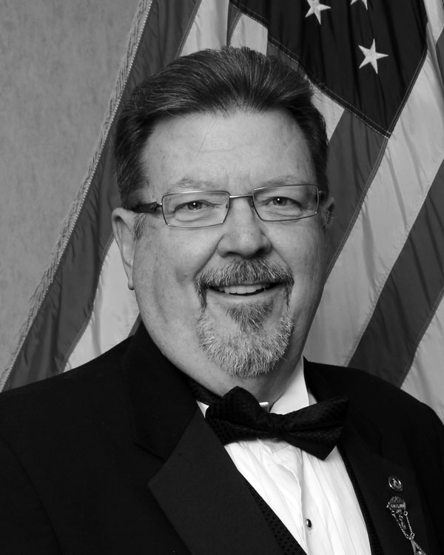From the Secretary  
Gary Wehr, PM

This is the second year that we (I) have posted the Dues Notice in the Trestleboard in order to save the Lodge money. Last year it didn’t seem to be a problem, this year, well let’s say it’s not going so well. This tells me two things. One, some people (well, many people) are not receiving the Trestleboard, and secondly if they are getting it, they are not reading it! I have to go with the second one. The Trestleboard is a topic of discussion at each and every officer’s meeting. There have been some past issues that are so boring that some members were using it instead of sleeping pills at night.

At the last officer’s meeting, we vowed to make it more interesting and more about Reynoldsburg Lodge. It will contain some Masonic education from time to time but this is Reynoldsburg Lodge’s newsletter and that’s what it should be about. If you have any suggestions to make it more interesting, please let us know. Since we are on the subject of the Trestleboard let me expand it a little further. The TB is about communicating with the members. There are times we need to communicate quicker with a quicker response from you, which leads me to my next request.

This will be my last year as secretary of Reynoldsburg Lodge. I want to leave this office more organized than when I started. That includes a more comprehensive email listing of the membership. I have several but over time, people change services for one reason or another.

Here is my request: Please send me an email. In it, please include the following:

1. Home number (or cell number if you prefer)  
2. Spouse’s name, if applicable  
3. Do you read the TB?  
4. Would you prefer an electronic version?

Please include any other thoughts or suggestions you have or want to contribute. This request is for EVERY member in Lodge. If you have more than one email address make sure to send this request from the one you want to receive Lodge communications.

Hopefully you are reading the Trestleboard, otherwise I’m writing this to myself!!

# **K:\DCIM\100CANON\Buck - TB_edited-1.jpg**From the Treasurer Bro. Buck Boyd

As most of you are aware, for quite a while we have been trying to find ways to control spending and costs. Each year I contact each of our vendors to try and negotiate lowering our costs or, at the very least, preventing an increase; sometimes it requires changing vendors. However, after years of doing this, we find that there is not much left that can be done.

For the past two years, we have tried to cut postage by putting dues notices in the Trestleboard. This has proven to be cost worthy, since the price of postage has gone up, and a good method of notification. However, it only works if you read your Trestleboard and respond.

This year we are setting up the option of paying dues with credit cards and using credit cards for other purposes, such as monthly breakfasts, Pride Case purchases, and more. We hope this helps you, the Brotherhood, in keeping your dues current and enabling more involvement with the lodge. The only drawback is that each transaction will have a small surcharge added, between 2.5 to 3 percent of the purchase total; the cost of doing business with the credit card company. If you would like to know more about this, read your Trestleboard or call WB Gary Wehr, Secretary, or Buck Boyd, Treasurer.

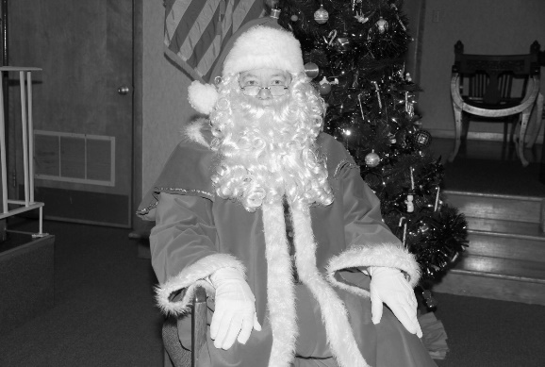I would like to thank everyone for their participation in this year’s Breakfast With Santa. We had over 138 people join us for breakfast, with many more just bringing their children and grandchildren to have their picture taken with Santa. Each child, adult, or family group received a beautiful picture provided by our Santa (WB Gary Wehr), and every child left with a Christmas bag full of goodies provided by the Lodge, with the help of Whitehall Lodge # 761, and donations from some of our business supporters. This year was the first year we asked for donations of non-perishable items to go to the Reynoldsburg Helping Hands organization. I am proud to say we were able to take 13 boxes full of goods to this great charity. We send our whole-hearted thanks to all!!

Last, our gratitude is extended to everyone who contributed to the lodge in 2014. We hope you will help make 2015 even better!

[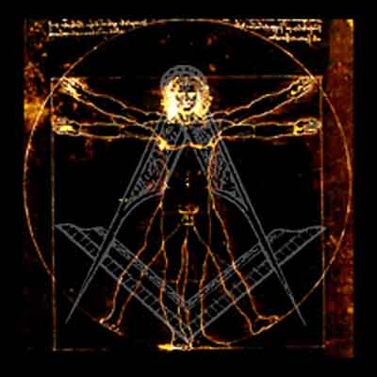](https://www.google.com/url?sa=i&rct=j&q=&esrc=s&frm=1&source=images&cd=&cad=rja&uact=8&ved=0CAcQjRw&url=https%3A%2F%2Fegregores.wordpress.com%2Fcategory%2Freligious-freedom%2Fpage%2F4%2F&ei=HrPBVOCYIIG8ggSN14G4Cw&bvm=bv.84349003,d.eXY&psig=AFQjCNHUq7CNksTEXliatdmIaih87dIGxA&ust=1422066740925221)

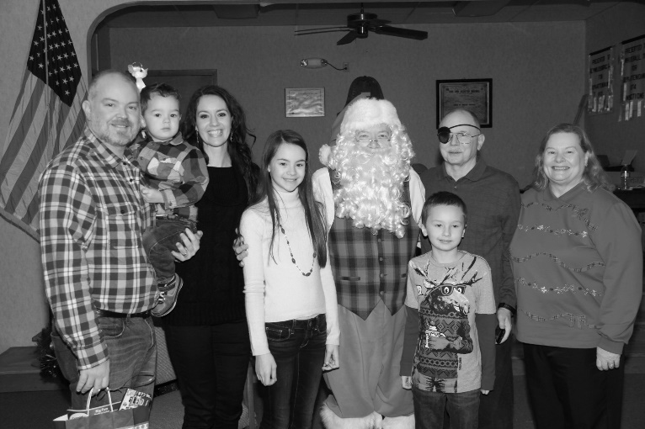

A Secretary's “Twas the Night Before Christmas”

'Twas the night before Christmas,  
and all through the Lodge  
Not a Brother was stirring, which was quite odd;  
The jewels were hung at the stations with care,  
In hopes that a Child would soon be there;  
WB Claus was all snug in his chair.

When out in the kitchen there arose such a clatter. Even the Past Masters awoke to see what was the matter.

It was the children, the children!!!! Coming in all sizes, shapes, and ages!

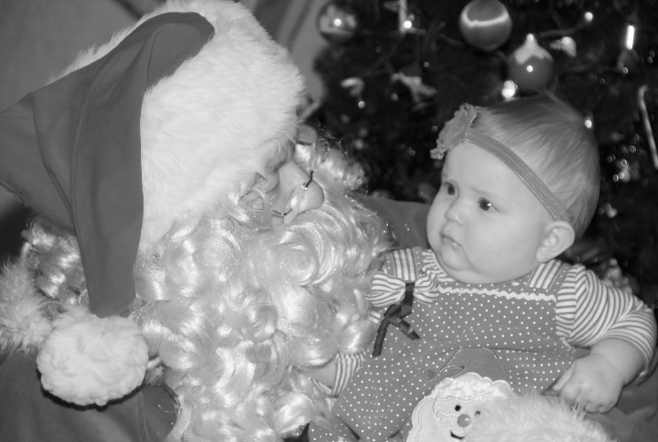Some children were excited to be there, some weren’t, and some didn’t even know what the heck was going on! However, in Santa’s eyes….

,

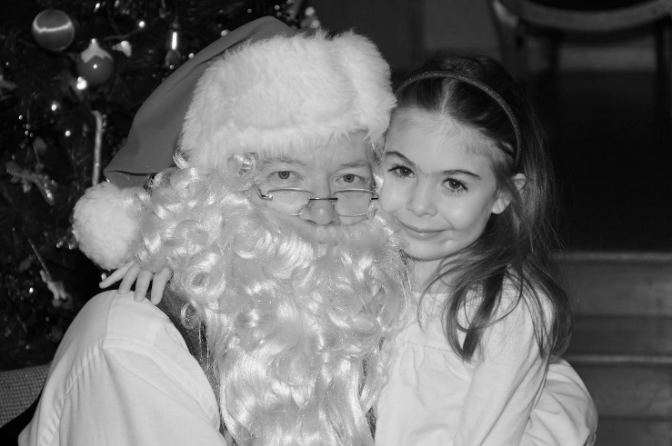They are all precious!

*HAPPY NEW YEAR!*

Pictures from the Breakfast with Santa on Dec 20, 2014)

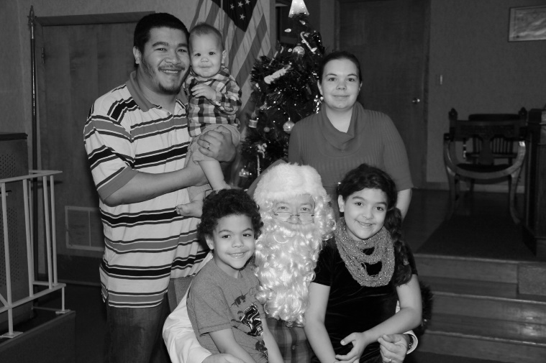

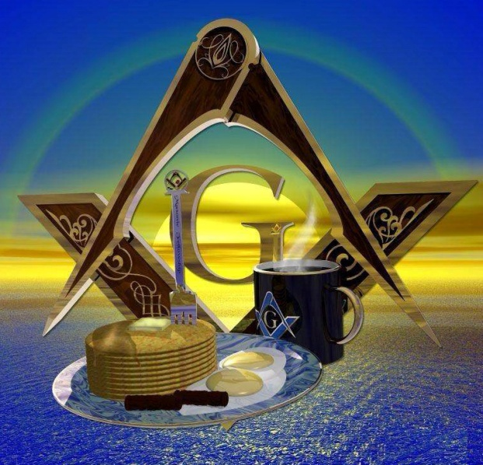

**Don’t forget our monthly breakfast on the last Saturday of EVERY month, 8-11am. All you can eat for $6. WHAT A DEAL!!!!!**

Rent the Lodge  
Got a big family gathering? Office party?  
Rent Godfrey Hall for your function  
Just $50 to rent Godfrey Hall   
for members of   
Reynoldsburg Lodge, Whitehall Lodge, or Eugenie Chapter  
Only $75 for non-members  
Additional Charge for kitchen use  
Contact WM Alex Jackson for details

[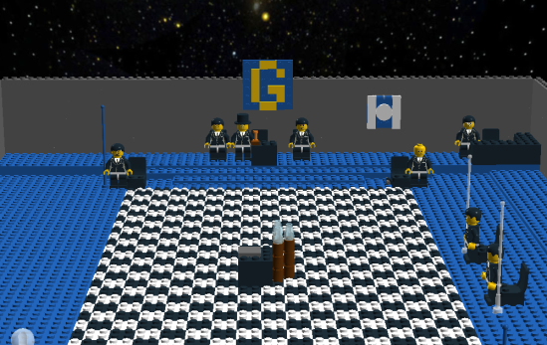](http://www.google.com/url?sa=i&rct=j&q=&esrc=s&frm=1&source=images&cd=&cad=rja&uact=8&ved=0CAcQjRw&url=http%3A%2F%2Fmasonictao.com%2F2012%2F12%2F24%2Flego-lodge-no-357%2F&ei=lLjBVOCtNIK1ggSX0IL4Cg&psig=AFQjCNHO4mO_41dk-qjcobgQs3LoxFc-tg&ust=1422068115085611)



**February**

1. Douglas Miller

8 Dan Hill

12 Forest Paxson

12 Donald Whybrew

13 Bill Peters, PM

14 James Myers

17 Donald Filmer

18 Donald Weilbacher

18 Mike Myers

18 John Trikouros

22 James Mathews

23 Harold Elliott, PM

23 Skip DeGonia, PM

23 Edward Rutherford

23 Dan Ellis

24 Richard McKinney

24 Brandon Hutchins

24 Chris Diaz

27 John Brogan

28 William Mills

28 John Pinkerton

28 Kevin Stone



**March**

1 Steven Reindel

1. Jerry Few
2. Melvin Hanley

6 James Glaze

7 Jim Audet, PM

9 Clarence Ransburgh

9 Robert Springer

9 Monroe Bradley

11 Louis Melmige

11 John Schaefer

16 Jim French

17 Andrew Mesaros

20 Richard Basye

20 Scott Edgel

20 Davy Moore

20 James Winslow

22 Stanley Gatterdam

25 Brad Arnold

28 Gary Wehr, PM

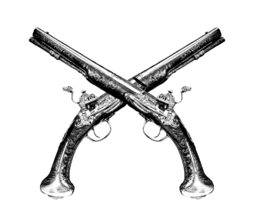

Gun Safety Educational Lecture

Given by Brother Jeff Mason

submitted by Bro Monroe Bradley, JW

At the December 2nd stated meeting, Bro Jeffrey Mason, who has extensive law enforcement experience especially in small arms tactical training gave an outstanding educational talk on gun safety. He began by poling the audience on the composition of their individual homes. He asked several questions. Do you have young children in the home? Do you have a spouse? Do you have older children in the home? He followed up by gauging everyone’s experience level.

He then asked about storage of the weapons. The point he made was that one must balance access with restricted access. He went on to make the point that one must also make decisions on the trade-off between different types of weapons. For example, a shoulder-fired weapon is more intimidating to an intruder, but might be more difficult to keep readily available for self-defense. On the other hand, a pistol is more accessible, but in a situation involving some level of close proximity to the assailant, there may be problems with the weapon retention. He admitted that the purpose of the lecture wasn’t to make anyone an expert, instead, he was able to begin a dialogue on a very important topic. If you have additional questions, please contact Brother Mason.

[](http://www.google.com/url?sa=i&rct=j&q=&esrc=s&frm=1&source=images&cd=&cad=rja&uact=8&ved=0CAcQjRw&url=http%3A%2F%2Fforums.1911forum.com%2Fshowthread.php%3Ft%3D385194%26page%3D3&ei=z7XBVMntBIqlgwStk4KgDg&bvm=bv.84349003,d.eXY&psig=AFQjCNGoNa71yMkYpTp3CD5CpVeJ9sQlrw&ust=1422067433881611)

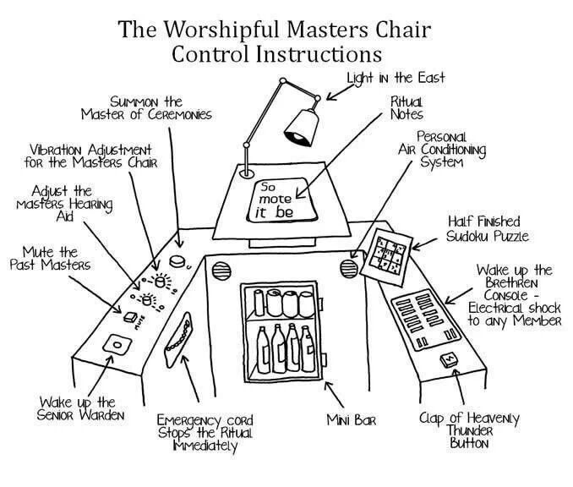

[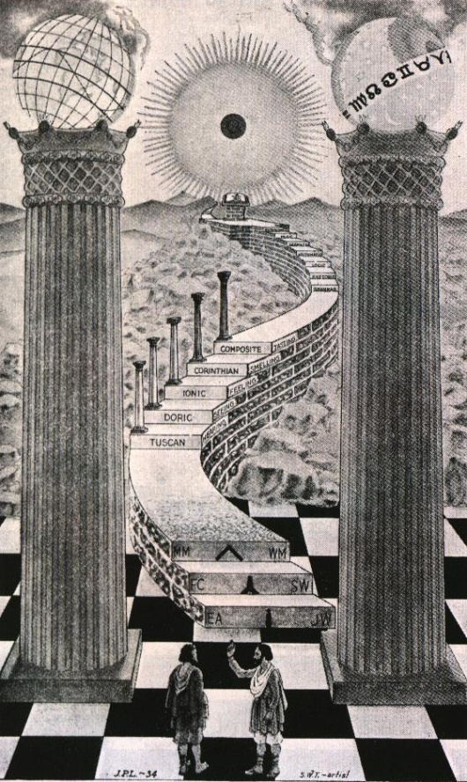](http://www.google.com/url?sa=i&rct=j&q=&esrc=s&frm=1&source=images&cd=&cad=rja&uact=8&ved=0CAcQjRw&url=http%3A%2F%2Ftracytwyman.com%2Fyear-zero-two-cubic-cities-and-the-pillars-of-heaven-excerpts-from-clock-shavings%2F&ei=IbXBVNPyHsy6ggSpwYOgCg&bvm=bv.84349003,d.eXY&psig=AFQjCNG35fBviR2JK3U-6o9cYh37XlwI9Q&ust=1422067260593233)

I SAT IN LODGE WITH YOU

There is a saying filled with cheer,

Which calls a man to fellowship.

It means as much for him to hear

As lies within the brother grip.

Nay, more! It opens wide the way

To friendliness sincere and true;

There are no strangers when you say

To me: "I sat in lodge with you."

When that is said, then I am known;

There is no questioning nor doubt;

I need not walk my path alone

Nor from my fellows be shut out.

Those words hold all of brotherhood

And help me face the world anew

There's something deep and rich and good

In this: "I sat in lodge with you."

Though in far lands one needs must roam

By sea and shore and hill and plain,

Those words bring him a touch of home

And lighten tasks that seem in vain.

Men's faces are no longer strange

But seem as those he always knew

When some one brings the joyous change

With this: "I sat in lodge with you."

So you, my brother, now and then

Have often put me in your debt

By showing forth to other men

That you your friends do not forget.

When all the world seems gray and cold

And I am weary, worn and blue

Then comes this golden thought I hold

You said: "I sat in lodge with you."

When to the last great Lodge you fare

My prayer is that I may be

One of your friends who wait you there

Intent your smiling face to see.

We, with the warden at the gate,

Will have a pleasant task to do;

We'll call, though you come soon or late:

"Come in! We sat in lodge with you!"



In Memorium – Most Worshipful Brother James Olmstead Past Grand Master

-

James Edward Olmstead, Past Grand Master of Ohio, passed away today, January 21, 2015. He was born on July 2, 1936, initiated an Entered Apprentice on February 3, 1969, passed to the degree of Fellow Craft on March 3, 1969, and raised a Master Mason on April 7, 1969 in Phoenix Lodge No. 123, Perrysburg, Ohio. Most Worshipful Brother Frederick Kelley, Past Grand Master of the Prince Hall Grand Lodge, and shown here with Most Worshipful Brother Olmstead, passed away late last year.

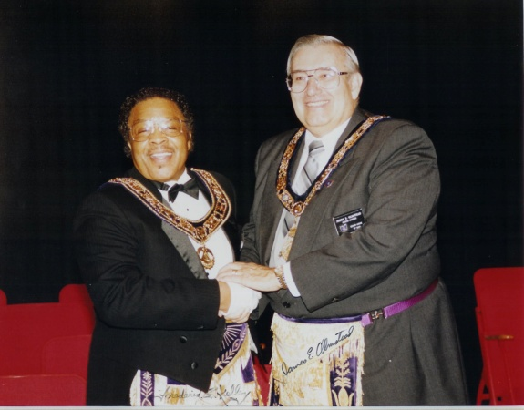

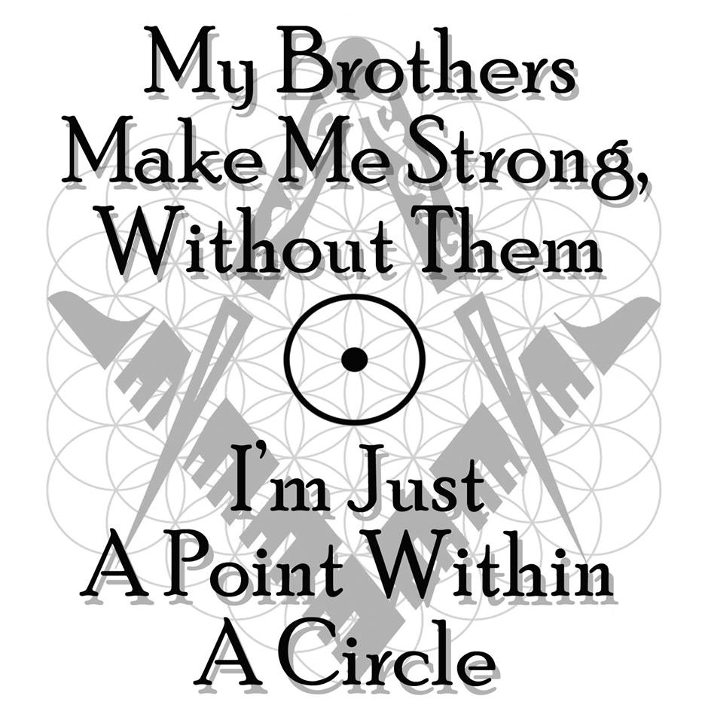From Freemason.com

# The Grand Lodge Charity Foundation

The Foundation was formed in 1994 under the leadership of Grand Master Thomas D. Zahler.  Its purpose is to invite, solicit, acquire, receive and accept gifts, bequests, devises and contributions and contract with donors for gift annuities for charitable, educational and scientific purposes.  The Foundation is operated separate and apart from the general activities of the Grand Lodge.  
  
It is important that you emphasize to you Lodges then importance of asking their members to support the Foundation and one of our most valued tenets, RELIEF.  
  
The President of the Charitable Foundation has the duty to process and secure information regarding the validity of all requests from Ohio residents for assistance.  He will then bring the details before the Foundation for actions.  Requests for assistance must start with a local lodge, whose responsibility it is to determine the validity of the request and the extent of the need.  If the Lodge believes the request is legitimate, it should do what it can to help locally as well as forward the documented request on to their District Deputy Grand Master, who will then communicate directly with the President of the Foundation.  
  
If there are questions about the process, Lodges should contact their District Deputy Grand Master for clarifications.  
  
Donations to support the work of the foundation can be made by sending a check, payable to the Grand Lodge Charitable Foundation, to The Grand Lodge of Ohio, 1 Masonic Drive, Springfield, Ohio 45504.  The Foundation is a 501(c)3 organization.

**Please support OUR SPONSORS**

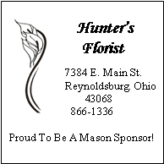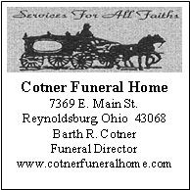

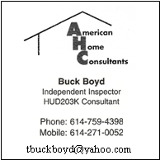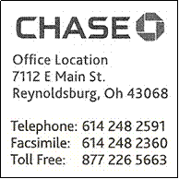



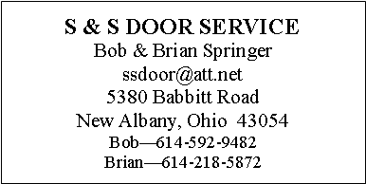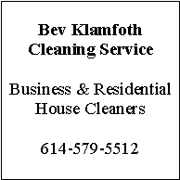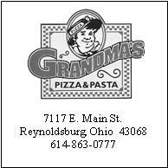

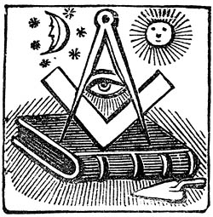

P.O. Box 624

Reynoldsburg Lodge #340 F&AM

Reynoldsburg, OH 43068

DATED MATERIAL – PLEASE DO NOT DELAY

NON-PROFIT ORGANIZATION  
U.S. POSTAGE PAID  
PERMIT NO. 30  
REYNOLDSBURG, OHIO 43068